SM -> In house Lobbyist --> Public Office Holder

1 : Many : Many

Example 2016 budget --> several lobbies --> each seeing several councillors.

When you select "list of".. all the "unique" version of "the of" is enumerated.

If the resultant list is > X, then all the values are shown. The user select one of the values which becomes the next search term.

Can you do predictive select boxes giving it a feed but we don't have values.

Business/Orgranization = ??

Client == Beneficiary where Type = 'Client'

**GrassRoots:** there is a json entity of

"Grassroots": {

"GRASSROOT": [{

"Community": "groups participating in campaign",

"Target": "poh group contact",

"EndDate": "2010-05-10",

"StartDate": "2010-04-27"

},

{

"Community": "<input type=\"text\">",

"Target": "<input type=\"text\">",

"EndDate": "2010-04-28",

"StartDate": "2010-04-27"

}]

},

On the overview page, it only shows the date. On the details if show community and target.

Comitte Organization:

"Meetings": {

"Meeting": [{

**"Committee": "Apple Inc.",**

"Date": "2012-07-16",

"Desc": ""

},

{

"Committee": "Apple Inc.",

"Date": "2012-07-18",

"Desc": ""

}]

},

Financial Contributions

"Privatefundings": {

"Privatefunding": [{

"Funding": "Contributor information",

"AgentContact": "Contributor information",

"Contact": "Contributor information",

"Agent": "Contributor information"

},

{

"Funding": "ac",

"AgentContact": "",

"Contact": "a",

"Agent": "a"

}]

},

Beneficiaries

"Firms": {

"Firm": [{

"FiscalEnd": "2010-05-06",

"FiscalStart": "2009-05-06",

"Name": "ACME",

"Description": "make money",

# Aggregator

1. **There is no “unique” or count option.**
2. **There is a field option. So you could select all on one field and determine the count via the number of rows returns. Similarly we could do a seach on each column we need to determine dropdown options…. But is this too expensive..**

**So the option of just putting search boxes on each column could be a good idea,**

**Use dataTables?? With deferred JSON read,, yes you on;y get numeric paging… but**

**So the only issue is when you have all the records but want an A-Z listing for lobbyist organizations etc…. but why not show the long number of pages,, then the user will know to put something in the search term.**

**How can you do the A,B,C thing unless you’ve read all the records.**

**How can we read all the lobbiest.. ie objects with contain an array of objects.**

**"SM" Object can contain many "Communication" objects**

**"SM" object can contain many "Firm" objects.**

**Category is a subject matter.**

## To get Count:

**Ajax fields="SMNumber" and count rows.**

## To get SM Filter

**Ajax fields="** SubjectMatter **, parse via ";" and weed out duplicates.. so a hash function.**

* **But expensive.**

## For A-Z Index

26 Parallel selects on Jason where limit = 1. With call back to 'remove' href

Comes in when alphanumeric report selected.--> so we requery

Do we need to worry about paging of alpha selectors.

In the current website, they page for more than 30 records. (so select 'A'. then page 1,2 for the 'A's.)

How does like work? Would would want

SM. Communications. Communication. LobbyistLastName like 'A*'

Typical JSON Row:

"SM": {

"Gmtfundings": {

"Gmtfunding": {

"GMTName": "Firefox",

"Program": "Firefox"

}

},

"Type": "Consultant",

"EffectiveDate": "2010-06-07",

"ProposedEndDate": "2010-06-30",

"ProposedStartDate": "2009-07-01",

"SMNumber": "SM11461",

"Status": "Active",

"Communications": {

"Communication": {

"PreviousPublicOfficeHoldLastDate": "",

"LobbyistBusinessAddress": {

"Phone": "",

"PostalCode": "",

"Country": "",

"Province": "",

"AddressLine1": "",

"City": "",

"AddressLine2": ""

},

"LobbyistFirstName": "",

"LobbyistMiddleInitials": "",

"CommunicationMethod": "",

"LobbyistType": "",

"LobbyistPrefix": "",

"LobbyistBusiness": "",

"LobbyistSuffix": "",

"PreviousPublicOfficePositionProgramName": "",

"POH_Position": "",

"POH_Name": "",

"POH_Office": "",

"PreviousPublicOfficeHoldPosition": "",

"CommunicationDate": "",

"PreviousPublicOfficeHolder": "",

"CommunicationGroupId": "",

"LobbyistLastName": "",

"LobbyistPositionTitle": "",

"POH_Type": "",

"LobbyistNumber": ""

}

},

"Privatefundings": {

"Privatefunding": {

"Funding": "Firefox",

"AgentContact": "Firefox",

"Contact": "Firefox",

"Agent": "Firefox"

}

},

"Particulars": "Firefox test",

"InitialApprovalDate": "2010-06-07",

"Grassroots": {

"GRASSROOT": {

"Community": "FirefoxFirefoxFirefox",

"Target": "FirefoxFirefoxFirefoxFirefox",

"EndDate": "2010-06-15",

"StartDate": "2010-06-07"

}

},

"Firms": {

"Firm": {

"FiscalEnd": "",

"FiscalStart": "",

"Name": "Firefox b",

"Description": "",

"TradeName": "",

"BusinessType": "",

"Type": "Consultant",

"BusinessAddress": {

"PostalCode": "Firefox",

"Country": "Firefox",

"Province": "Firefox",

"AddressLine1": "Firefox",

"City": "Firefox",

"AddressLine2": ""

}

}

},

"Registrant": {

"PreviousPublicOfficeHoldLastDate": "2010-06-01",

"PositionTitle": "Firefox",

"Type": "Consultant",

"Suffix": "",

"EffectiveDate": "2010-06-07",

"Prefix": "",

"LastName": "Firefox c",

"PreviousPublicOfficePositionProgramName": "Firefox",

"RegistrationNUmberWithSoNum": "12081C",

"Status": "Active",

"RegistrationNUmber": "12081C",

"PreviousPublicOfficeHoldPosition": "Firefox",

"FirstName": "Firefox c",

"PreviousPublicOfficeHolder": "Yes",

"MiddleInitials": "",

"BusinessAddress": {

"Phone": "Firefox",

"PostalCode": "Firefox",

"Country": "Firefox",

"Province": "Firefox",

"AddressLine1": "Firefox",

"City": "Firefox",

"AddressLine2": ""

}

},

"Beneficiaries": {

"BENEFICIARY": {

"FiscalEnd": "",

"FiscalStart": "",

"Name": "Firefox",

"TradeName": "",

"Type": "Client",

"BusinessAddress": {

"PostalCode": "Firefox",

"Country": "Firefox",

"Province": "Firefox",

"AddressLine1": "Firefox",

"City": "Firefox",

"AddressLine2": ""

}

}

},

"SubjectMatter": "Arts / Culture;Attractions / Tourism"

}

},

{

"SM": {

"Type": "In-house",

"EffectiveDate": "2010-06-07",

"Meetings": {

"Meeting": [{

"Committee": "Committee1",

"Date": "2010-06-01",

"Desc": ""

},

{

"Committee": "Committee1",

"Date": "2010-06-09",

"Desc": ""

},

{

"Committee": "Committee2",

"Date": "2010-06-15",

"Desc": ""

}]

},

"ProposedEndDate": "2010-06-30",

"ProposedStartDate": "2009-06-01",

"SMNumber": "SM11462",

"Status": "Active",

"Communications": {

"Communication": {

"PreviousPublicOfficeHoldLastDate": "",

"LobbyistBusinessAddress": {

"Phone": "Firefox Inhouse",

"PostalCode": "Firefox Inhouse",

"Country": "Firefox Inhouse",

"Province": "Firefox Inhouse",

"AddressLine1": "Firefox Inhouse",

"City": "Firefox Inhouse",

"AddressLine2": ""

},

"LobbyistFirstName": "Firefox Inhouse FN c",

"LobbyistMiddleInitials": "",

"CommunicationMethod": "",

"LobbyistType": "Sr. Officer",

"LobbyistPrefix": "",

"LobbyistBusiness": "",

"LobbyistSuffix": "",

"PreviousPublicOfficePositionProgramName": "",

"POH_Position": "",

"POH_Name": "",

"POH_Office": "",

"PreviousPublicOfficeHoldPosition": "",

"CommunicationDate": "",

"PreviousPublicOfficeHolder": "no",

"CommunicationGroupId": "",

"LobbyistLastName": "Firefox Inhouse LN",

"LobbyistPositionTitle": "Firefox Inhouse",

"POH_Type": "",

"LobbyistNumber": "12082S-1"

}

},

"GMTFUNDINGS": {

"GMTFUNDING": [{

"GMTName": "sdfa",

"Program": "sadf"

},

{

"GMTName": "sdf",

"Program": "sd"

}]

},

"Particulars": "Firefox Inhouse",

"InitialApprovalDate": "2010-06-07",

"Grassroots": {

"GRASSROOT": {

"Community": "dsafs",

"Target": "asdfsdf",

"EndDate": "2010-06-15",

"StartDate": "2010-06-07"

}

},

"Firms": {

"Firm": [{

"FiscalEnd": "2010-06-30",

"FiscalStart": "2009-06-01",

"Name": "Firefox Inhouse",

"Description": "Firefox Inhouse Firefox Inhouse Firefox Inhouse Firefox Inhouse",

"TradeName": "",

"BusinessType": "Not-for-profit grant applicant",

"Type": "In-house",

"BusinessAddress": {

"PostalCode": "Firefox Inhouse",

"Country": "Firefox Inhouse",

"Province": "Firefox Inhouse",

"AddressLine1": "Firefox Inhouse",

"City": "Firefox Inhouse",

"AddressLine2": ""

}

},

{

"FiscalEnd": "",

"FiscalStart": "",

"Name": "Firefox Inhouse",

"Description": "",

"TradeName": "Firefox Inhouse",

"BusinessType": "",

"Type": "Other",

"BusinessAddress": {

"PostalCode": "Firefox Inhouse",

"Country": "Firefox Inhouse",

"Province": "Firefox Inhouse",

"AddressLine1": "Firefox Inhouse",

"City": "Firefox Inhouse",

"AddressLine2": ""

}

},

{

"FiscalEnd": "",

"FiscalStart": "",

"Name": "Firefox Inhouse",

"Description": "",

"TradeName": "",

"BusinessType": "",

"Type": "Subsidiary",

"BusinessAddress": {

"PostalCode": "Firefox Inhouse",

"Country": "Firefox Inhouse",

"Province": "Firefox Inhouse",

"AddressLine1": "Firefox Inhouse",

"City": "Firefox Inhouse",

"AddressLine2": ""

}

}]

},

"Registrant": {

"PreviousPublicOfficeHoldLastDate": "",

"PositionTitle": "Firefox Inhouse",

"Type": "In-house",

"Suffix": "",

"EffectiveDate": "2010-06-07",

"Prefix": "",

"LastName": "Firefox Inhouse LN",

"PreviousPublicOfficePositionProgramName": "",

"RegistrationNUmberWithSoNum": "12082S-1",

"Status": "Active",

"RegistrationNUmber": "12082S",

"PreviousPublicOfficeHoldPosition": "",

"FirstName": "Firefox Inhouse FN c",

"PreviousPublicOfficeHolder": "no",

"MiddleInitials": "",

"BusinessAddress": {

"Phone": "Firefox Inhouse",

"PostalCode": "Firefox Inhouse",

"Country": "Firefox Inhouse",

"Province": "Firefox Inhouse",

"AddressLine1": "Firefox Inhouse",

"City": "Firefox Inhouse",

"AddressLine2": ""

}

},

"SubjectMatter": "Arts / Culture;Building Inspection;Planning and Development, Planning Policy / Study"

}

},

So In his signature t6able…

He out a table with one td and in that TD he used Bootstrap grid. Why??

For lobbiest View:

Need to loop at SM, loop at communication

* Create lobbiest row.

BUsi

BootStrap in Prod

No stripped tables?? Doesn't seem to be a css for even rows in tables.

# Terminology

|  |
| --- |
|  |
|  | [**>>> Consultant lobbyist**](javascript:openPopupWindow('/lobbyistregistry/lobbyistRegister10.do?Voluntary=No')) |  |  |  |
|  |  | A consultant lobbyist is a person who lobbies on behalf of a client/ business/ organization for payment. A consultant lobbyist is also a person who arranges meetings between public office holders and any other person for the purpose of lobbying. |  |  |  |
|  |  |  |  |  |  |
|  |  | [**>>> In-house lobbyist**](javascript:openPopupWindow('/lobbyistregistry/lobbyistRegister00.do?First=Yes')) |  |  |  |
|  |  | An in-house lobbyist is defined as either: (a) an employee of an individual, corporation, organization or other person, or a partnership, whose duties include lobbying on behalf of the employer or its subsidiary, (b) the sole proprietor of a business, who is lobbying on behalf of the business, or (c) a partner in a business, who is lobbying on behalf of the partnership. |  |  |  |
|  |  |  |  |  |  |
|  |  | [**>>> Voluntary lobbyist**](javascript:openPopupWindow('/lobbyistregistry/lobbyistRegister10.do?Voluntary=Yes')) |  |  |  |
|  |  | Voluntary lobbyists volunteer to lobby for a business or for-profit organization as outlined above. |  |  |  |

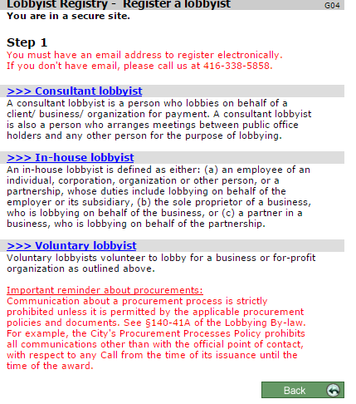

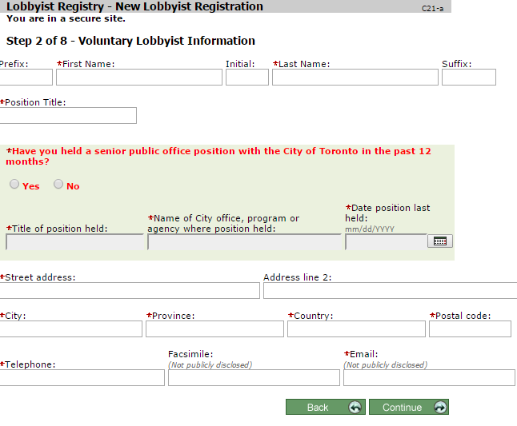

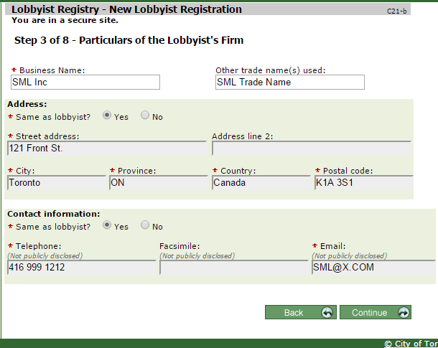

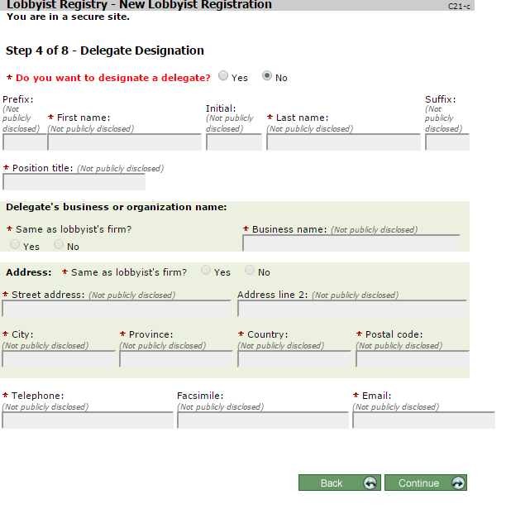

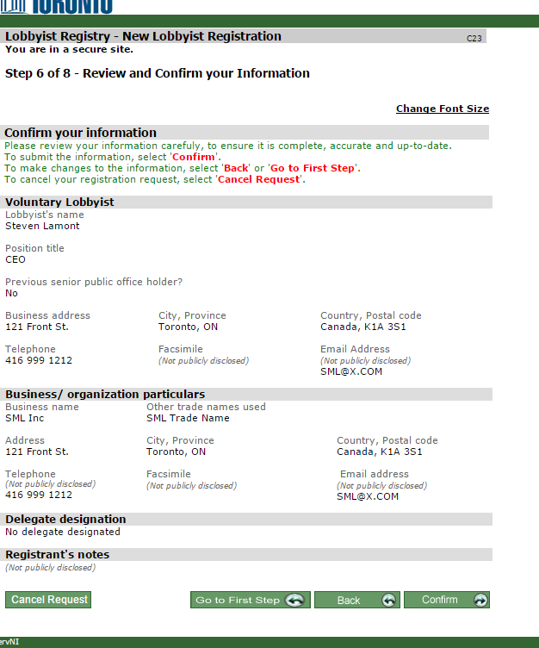

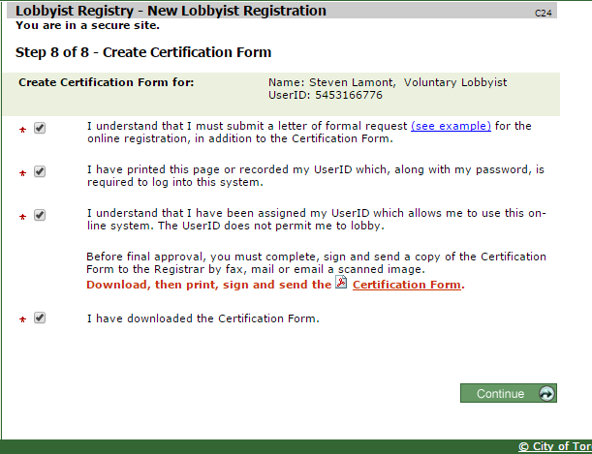

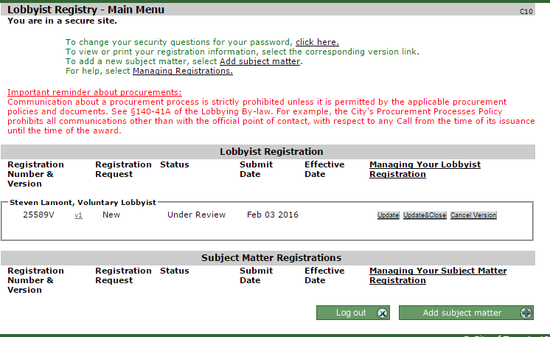

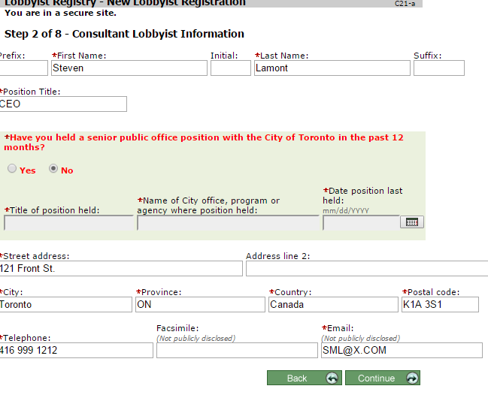

# Subject Matters

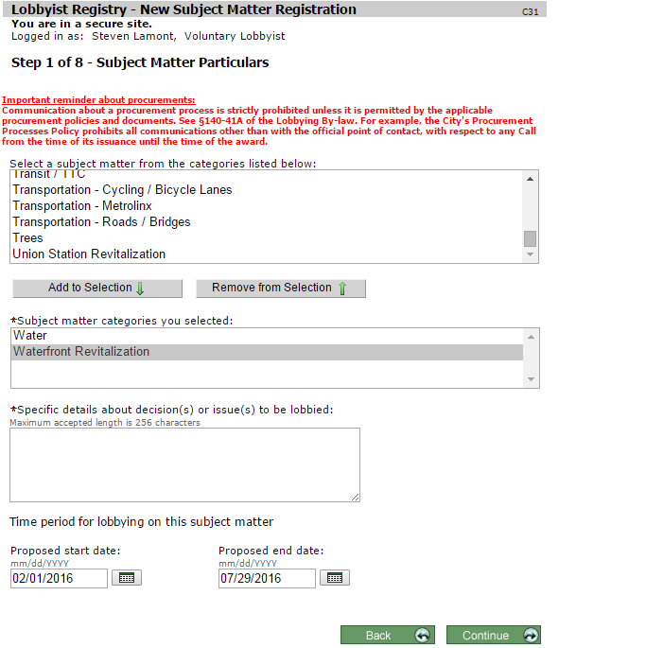

A lobbyist creates a subject matter on behalf of a client.

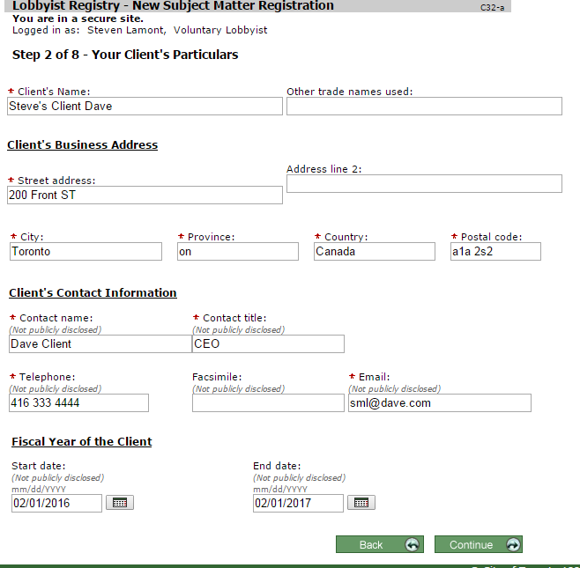

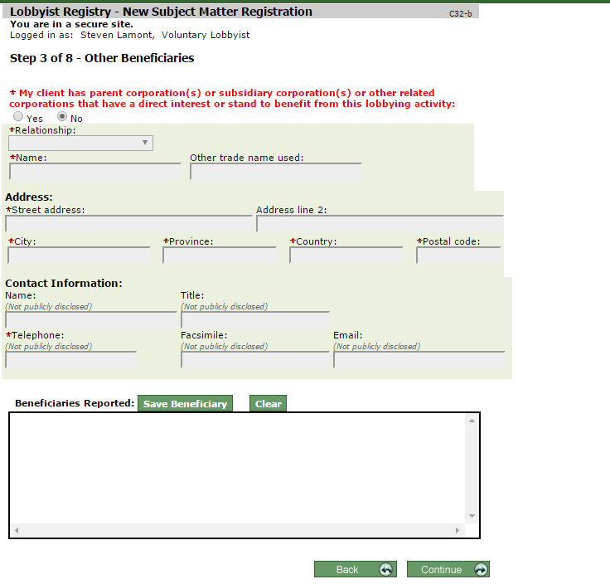

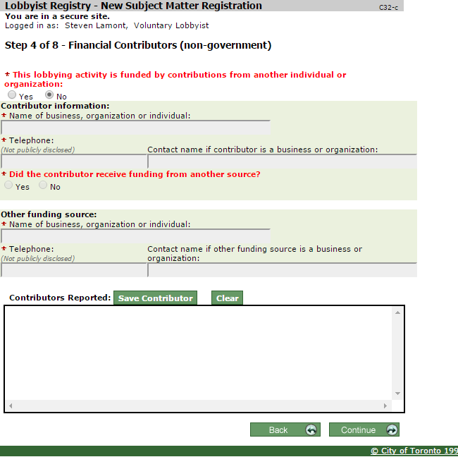

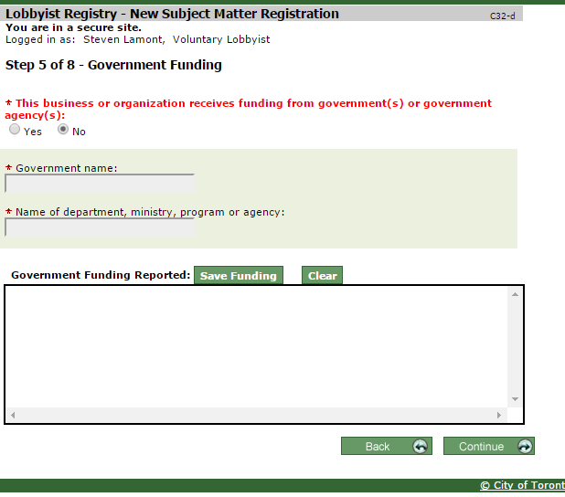

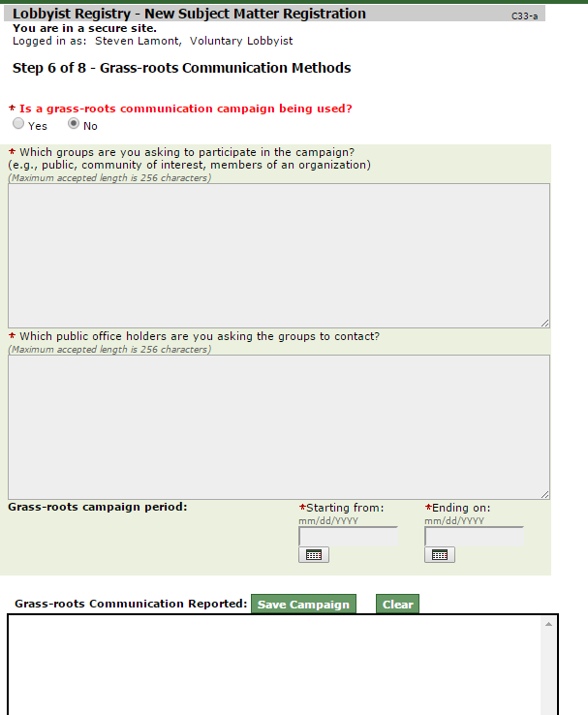

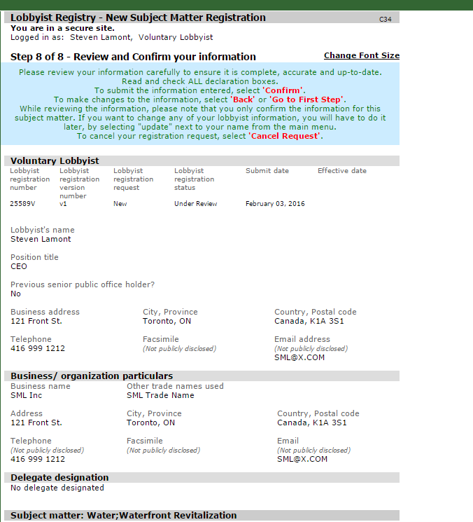

Summary

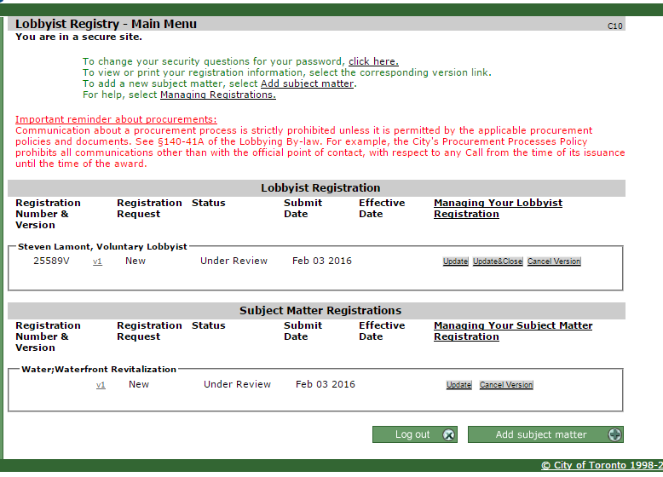

In House Lobbyist

Page 1: enter Senior Office Info

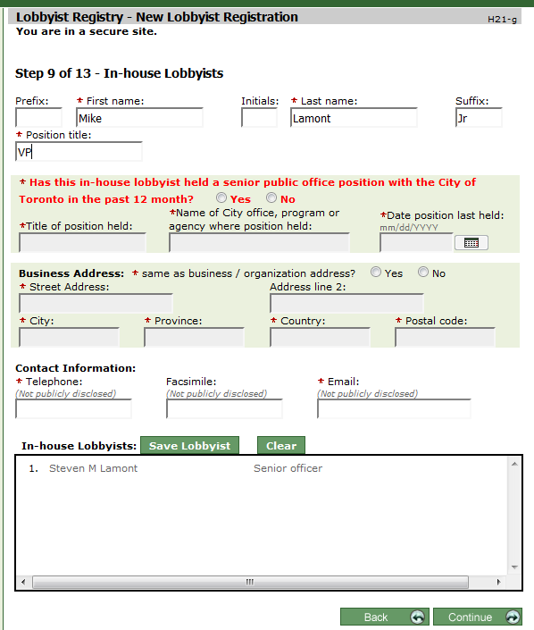

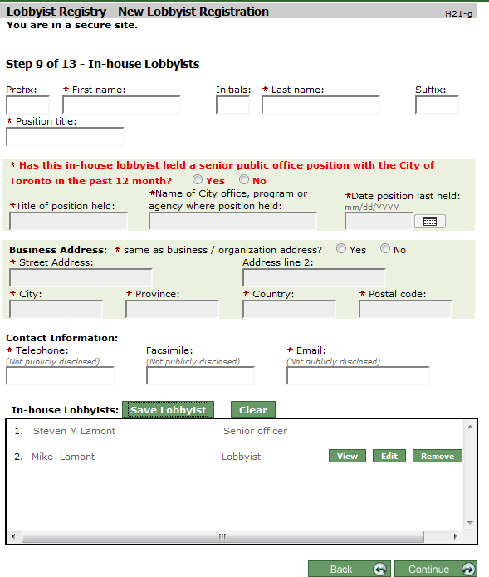

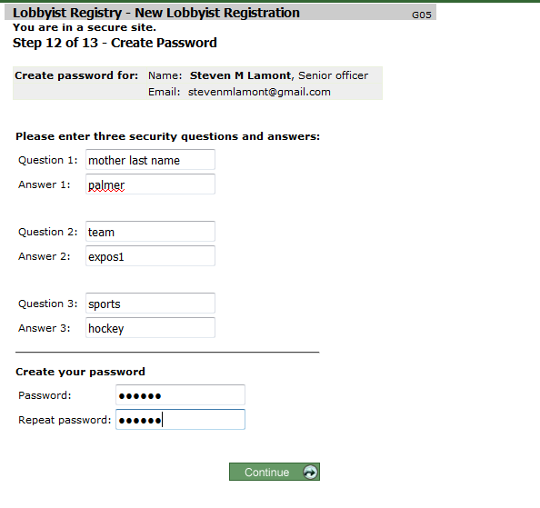

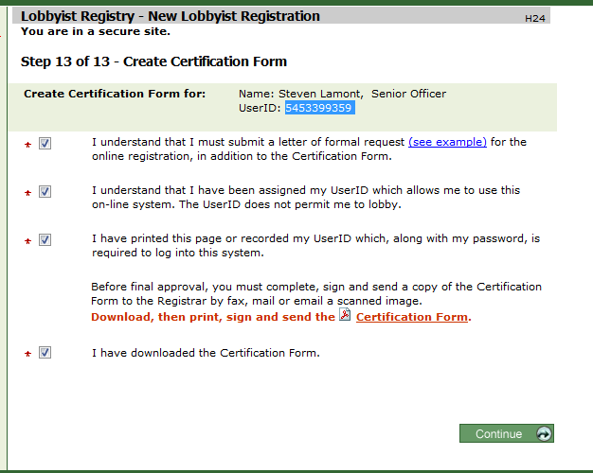

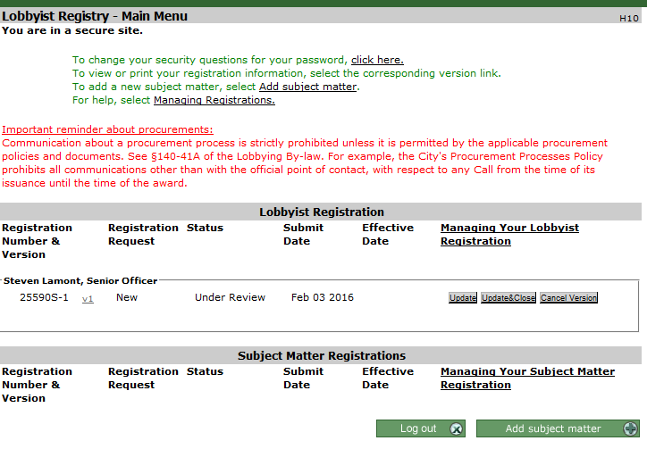

22590S-1 is the registration #5453399359

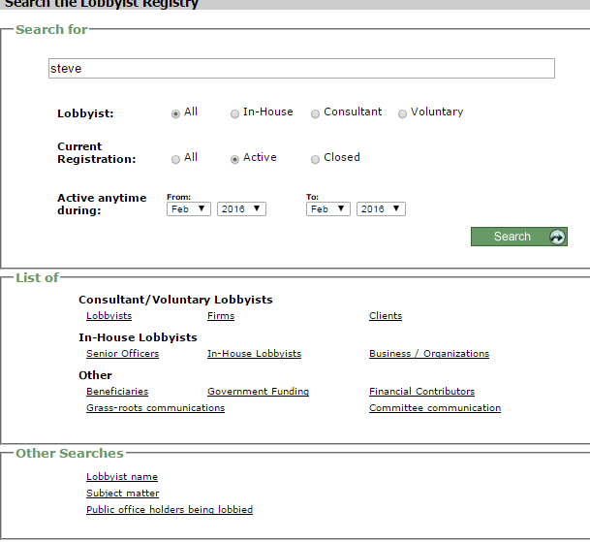

Lobbyist: There are three types when you register. (in house, consultant, voluntary)

Firms

A registration is you registering to lobby…

You can add subject matters to your registration. Subject matters have a type if "In-House" and "Consultant" and Voluntary based on the Registration typ

Registration --> SMs

In House Lobbyist:

1) you specify the senior Officer of the firm.

"SM": {

"Type": "Voluntary",

"EffectiveDate": "2014-04-14",

"ProposedEndDate": "2015-02-12",

"ProposedStartDate": "2011-09-09",

"SMNumber": "SM17044",

"Status": "Active",

"Communications": {

"Communication": {

"PreviousPublicOfficeHoldLastDate": "",

"LobbyistBusinessAddress": {

"Phone": "",

"PostalCode": "",

"Country": "",

"Province": "",

"AddressLine1": "",

"City": "",

"AddressLine2": ""

},

"LobbyistFirstName": "",

"LobbyistMiddleInitials": "",

"CommunicationMethod": "",

"LobbyistType": "",

"LobbyistPrefix": "",

"LobbyistBusiness": "",

"LobbyistSuffix": "",

"PreviousPublicOfficePositionProgramName": "",

"POH_Position": "",

"POH_Name": "",

"POH_Office": "",

"PreviousPublicOfficeHoldPosition": "",

"CommunicationDate": "",

"PreviousPublicOfficeHolder": "",

"CommunicationGroupId": "",

"LobbyistLastName": "",

"LobbyistPositionTitle": "",

"POH_Type": "",

"LobbyistNumber": ""

}

},

"Particulars": "The relocation of Don Mills arena from it's current location at Don Mills Plaza to a new location on City owned lands. The new location to be lobbied is the Northwest corner of York Mills Rd and the DVP (the decommissioned on ramp of approx. 7 acres.",

"InitialApprovalDate": "2011-09-07",

"Registrant": {

"PreviousPublicOfficeHoldLastDate": "",

"PositionTitle": "President T.P.A. Events",

"Type": "Consultant",

"Suffix": "",

"EffectiveDate": "2009-04-28",

"Prefix": "",

"LastName": "Kinsella",

"PreviousPublicOfficePositionProgramName": "",

"RegistrationNUmberWithSoNum": "13738V",

"Status": "Active",

"RegistrationNUmber": "13738V",

"PreviousPublicOfficeHoldPosition": "",

"FirstName": "Bradley",

"PreviousPublicOfficeHolder": "No",

"MiddleInitials": "B",

"BusinessAddress": {

"Phone": "416 893 0261",

"PostalCode": "M2J 1R5",

"Country": "Canada",

"Province": "Ontario",

"AddressLine1": "180 Yorkland Blvd",

"City": "Toronto",

"AddressLine2": ""

}

},

"Beneficiaries": {

"BENEFICIARY": {

"FiscalEnd": "2013-05-21",

"FiscalStart": "2012-05-31",

"Name": "Brad Kinsella",

"TradeName": "",

"Type": "Client",

"BusinessAddress": {

"PostalCode": "M3A 3G2",

"Country": "Canada",

"Province": "Ontario",

"AddressLine1": "11 Barnwood Court",

"City": "Toronto",

"AddressLine2": ""

}

}

},

"Firms": {

"Firm": {

"FiscalEnd": "",

"FiscalStart": "",

"Name": "T.P.A. Events",

"Description": "",

"TradeName": "",

"BusinessType": "",

"Type": "Consultant",

"BusinessAddress": {

"PostalCode": "M2J 1R5",

"Country": "Canada",

"Province": "Ontario",

"AddressLine1": "180 Yorkland Blvd",

"City": "Toronto",

"AddressLine2": ""

}

}

},

"SubjectMatter": "Grants / Funding;Real Estate / Property (City-owned);Recreation"

}

},

Data Facts:

1)

* There is one Registrant of a SM.
* The registrant has a TYPE: Consultant or In-House.
* The registrant is 'Active' or 'Closed' independently of the SM. (I assume the Registrant is a separate entity and added to SM in the JSON feed)
* If you sign-up as a voluntary lobbyist, the registrant type = 'Consulatant'

Registrant": {

"PreviousPublicOfficeHoldLastDate": "",

"PositionTitle": "Principal",

"Type": "Consultant",

"Suffix": "",

"EffectiveDate": "2012-10-26",

"Prefix": "Mr.",

"LastName": "Besner",

"PreviousPublicOfficePositionProgramName": "",

"RegistrationNUmberWithSoNum": "10225C",

"Status": "Active",

"RegistrationNUmber": "10225C",

"PreviousPublicOfficeHoldPosition": "",

"FirstName": "Jamie",

"PreviousPublicOfficeHolder": "No",

"MiddleInitials": "",

"BusinessAddress": {

"Phone": "416-961-6611",

"PostalCode": "M5J 2H7",

"Country": "Canada",

"Province": "Ontario",

"AddressLine1": "55 University Avenue",

"City": "Toronto",

"AddressLine2": "Suite 600"

}

},

2) Beneficiaries

* There can be one or more beneficiaries
* The 'Client' is the beneficiary with a Type of 'Client'

Example 1:

"Beneficiaries": {

"BENEFICIARY": {

"FiscalEnd": "2009-12-31",

"FiscalStart": "2009-01-01",

"Name": "Clear Channel Outdoor Canada",

"TradeName": "",

"Type": "Client",

"BusinessAddress": {

"PostalCode": "M5G 2C2",

"Country": "Canada",

"Province": "Ontario",

"AddressLine1": "20 Dundas Street",

"City": "Toronto",

"AddressLine2": ""

}

}

},

Example 2:

"Beneficiaries": {

"BENEFICIARY": [{

"FiscalEnd": "",

"FiscalStart": "",

"Name": "Acme Business Machines",

"TradeName": "",

"Type": "Client",

"BusinessAddress": {

"PostalCode": "M5H 2N2",

"Country": "Canada",

"Province": "ON",

"AddressLine1": "123 Yonge St",

"City": "Toronto",

"AddressLine2": ""

}

},

{

"FiscalEnd": "",

"FiscalStart": "",

"Name": "Canada Business Machines",

"TradeName": "",

"Type": "Parent company",

"BusinessAddress": {

"PostalCode": "K5M 3H4",

"Country": "Canada",

"Province": "ON",

"AddressLine1": "45 Hill St",

"City": "Ottawa",

"AddressLine2": ""

}

}]

3) Firms

* There are one or more firms for a SM.
* For the registrant, you enter a business/org particulars and an org type of
  + Corporation, sole proprietor etc. (no subsidiary listed!!)
  + At the end of the form you can add "other beneficiaries)
    - Which are Parent, Subsidiary or Other

"Firms": {

"Firm": [{

"FiscalEnd": "2015-05-31",

"FiscalStart": "2014-06-01",

"Name": "A member of the Great Gulf Group of Companies",

"Description": "High Rise mixed use development company focused primarily on downtown high density projects.",

"TradeName": "",

"BusinessType": "Corporation",

"Type": "In-house",

"BusinessAddress": {

"PostalCode": "M1W 3Z4",

"Country": "Canada",

"Province": "ON",

"AddressLine1": "3751 Victoria Park Avenue",

"City": "Toronto",

"AddressLine2": ""

}

},

{

"FiscalEnd": "",

"FiscalStart": "",

"Name": "First Gulf Corporation",

"Description": "",

"TradeName": "First Gulf",

"BusinessType": "",

"Type": "Subsidiary",

"BusinessAddress": {

"PostalCode": "M1W 3Z4",

"Country": "Canada",

"Province": "ON",

"AddressLine1": "3751 Victoria Park Ave.",

"City": "Toronto",

"AddressLine2": ""

}

}]

},

4) Senior Officer –

* Is the registrant and will show up as such on the SM details.
* If you pick the senior office to be the in-house lobbyist, then a record is shown in the communications with senior officer listed.
* If you look at senior lobbyist from their existing screens, it doesn't consider registrants. Ie) it only looks at senior lobbyists doing lobbying.
* There is no senior officer on a Voluntary Registrant.

5) Lobbyist Names:

* Take the Registrant (is Senior Lobbyist)
* Add in all communication records

6) Lobbyist Type:

* The registrant has a TYPE: Consultant or In-House.
* The Lobbyist Type should change to "Sr. Officer" and ignore the Registrant Type?

Proposed:

* + The Lobbyist Type becomes the TYPE of SM
  + SM = Voluntary --> Lobbyist Type = Voluntary
  + SM = Consultant ==> Lobby Type Consultant.
  + SM = In-House --> Lobby Type = "Sr. Office" for registrant, In-House LobbyIst for other

Lobbyist Names:

Names, Businness/Org is Name on the Firm that is not "parent, subsidiary, other', Type = "in-house, sor officer. This is not on the communication records.

POH: Principal Office Holder.

* Notice name is not first/last, so it would be hard to query and order by last name

"Communications" : {

"Communication" : {

"PreviousPublicOfficeHoldLastDate" : "",

"LobbyistBusinessAddress" : {

"Phone" : "613 555 1212",

"PostalCode" : "k2L 1X1",

"Country" : "CAN",

"Province" : "ON",

"AddressLine1" : "21 Bank St",

"City" : "Otatwa",

"AddressLine2" : ""

},

"LobbyistFirstName" : "Mike",

"LobbyistMiddleInitials" : "",

"CommunicationMethod" : "",

"LobbyistType" : "In-House Lobbyist",

"LobbyistPrefix" : "",

"LobbyistBusiness" : "",

"LobbyistSuffix" : "Jr",

"PreviousPublicOfficePositionProgramName" : ".",

"POH_Position" : "",

"POH_Name" : "",

"POH_Office" : "",

"PreviousPublicOfficeHoldPosition" : ".",

"CommunicationDate" : "",

"PreviousPublicOfficeHolder" : "no",

"CommunicationGroupId" : "",

"LobbyistLastName" : "Lamont",

"LobbyistPositionTitle" : "VP",

"POH_Type" : "",

"LobbyistNumber" : "25591H"

}

},

Userid: 5453166776 - voluntary

5453399359 – snr officer

# Search For:

Active is for Registrant and is not related to the SM.

# List of Usage:

1) Lobbyist – Use lobbyist Name report

2) Firms

3) Client Is on all reports. Can Filter it.

**Other** – These show lists of values whether they are active/close or not.. when you select them, nothing may hit

Beneficiaries – Is this a list of all Beneficiaries or those that are not clients?

* The current screen seems to show all beneficiaries (active or not).

GrassRoots: Not sure I understand this. We could key on Community/Target

"Grassroots": {

"GRASSROOT": {

"Community": "Public",

"Target": "all councillors",

"EndDate": "2015-07-28",

"StartDate": "2015-07-14"

}

},

Committee Meeting:

**"Meetings" : {**

**"Meeting" : {**

**"Committee" : "Government Relations Committee",**

"Date" : "2011-05-16",

"Lobbyists" : {

"Lobbyist" : [{

"Business" : "",

"Type" : "In-House Lobbyist",

"Suffix" : "",

"Number" : "10342H",

"FirstName" : "Von",

"Prefix" : "",

"LastName" : "Palmer",

"MiddleInitials" : ""

}, {

"Business" : "",

"Type" : "Committee Member",

"Suffix" : "",

"Number" : "15967H",

"FirstName" : "Calvin",

"Prefix" : "",

"LastName" : "Weinfeld",

"MiddleInitials" : ""

}, {

"Business" : "",

"Type" : "Committee Member",

"Suffix" : "",

"Number" : "15966H",

"FirstName" : "Dianne",

"Prefix" : "",

"LastName" : "Usher",

"MiddleInitials" : ""

}, {

"Business" : "",

"Type" : "Committee Member",

"Suffix" : "",

"Number" : "15965H",

"FirstName" : "Sophia",

"Prefix" : "",

"LastName" : "Tang",

"MiddleInitials" : ""

}, {

"Business" : "",

"Type" : "Committee Member",

"Suffix" : "",

"Number" : "15964H",

"FirstName" : "Maureen",

"Prefix" : "",

"LastName" : "Sullivan",

"MiddleInitials" : ""

}, {

"Business" : "",

"Type" : "Committee Member",

"Suffix" : "",

"Number" : "15963H",

"FirstName" : "Johnmark",

"Prefix" : "",

"LastName" : "Roberts",

"MiddleInitials" : ""

}, {

"Business" : "",

"Type" : "Committee Member",

"Suffix" : "",

"Number" : "15961H",

"FirstName" : "Joe",

"Prefix" : "",

"LastName" : "Panchyshyn",

"MiddleInitials" : ""

}, {

"Business" : "",

"Type" : "Committee Member",

"Suffix" : "",

"Number" : "15960H",

"FirstName" : "Tony",

"Prefix" : "",

"LastName" : "Luke",

"MiddleInitials" : ""

}, {

"Business" : "",

"Type" : "Committee Member",

"Suffix" : "",

"Number" : "15959H",

"FirstName" : "Lydia",

"Prefix" : "",

"LastName" : "Ingles",

"MiddleInitials" : ""

}, {

"Business" : "",

"Type" : "Committee Member",

"Suffix" : "",

"Number" : "15957H",

"FirstName" : "Michael",

"Prefix" : "",

"LastName" : "Dosman",

"MiddleInitials" : ""

}, {

"Business" : "",

"Type" : "Committee Member",

"Suffix" : "",

"Number" : "15956H",

"FirstName" : "Henry",

"Prefix" : "",

"LastName" : "David",

"MiddleInitials" : ""

}, {

"Business" : "",

"Type" : "Committee Member",

"Suffix" : "",

"Number" : "15954H",

"FirstName" : "Michael",

"Prefix" : "",

"LastName" : "Collins",

"MiddleInitials" : ""

}, {

"Business" : "",

"Type" : "Committee Member",

"Suffix" : "",

"Number" : "15953H",

"FirstName" : "Anne",

"Prefix" : "",

"LastName" : "Briscoe",

"MiddleInitials" : ""

}, {

"Business" : "",

"Type" : "Committee Member",

"Suffix" : "",

"Number" : "15952H",

"FirstName" : "Stuart",

"Prefix" : "",

"LastName" : "Braund",

"MiddleInitials" : ""

}, {

"Business" : "",

"Type" : "In-House Lobbyist",

"Suffix" : "",

"Number" : "16867H",

"FirstName" : "Cynthia",

"Prefix" : "",

"LastName" : "Lee",

"MiddleInitials" : ""

}, {

"Business" : "",

"Type" : "In-House Lobbyist",

"Suffix" : "",

"Number" : "10343H",

"FirstName" : "Mauro",

"Prefix" : "",

"LastName" : "Ritacca",

"MiddleInitials" : ""

}

]

},

"POHS" : {

"POH" : {

"Name" : "Doug Ford",

"Type" : "Member of Council",

"Office" : "Ward 2 Etobicoke North",

"Title" : "Councillor"

}

},

POH: Public Office Holder

* notice they show uo in separate entities for committees

"POH_Position" : "Councillor",

"POH_Name" : "Pam McConnell",

"POH_Office" : "Ward 28 Toronto Centre-Rosedale"

"POH_Type" : "Member of Council",

"Communications" : {

"Communication" : {

"PreviousPublicOfficeHoldLastDate" : "",

"LobbyistBusinessAddress" : {

"Phone" : "613 555 1212",

"PostalCode" : "k2L 1X1",

"Country" : "CAN",

"Province" : "ON",

"AddressLine1" : "21 Bank St",

"City" : "Otatwa",

"AddressLine2" : ""

},

"LobbyistFirstName" : "Mike",

"LobbyistMiddleInitials" : "",

"CommunicationMethod" : "",

"LobbyistType" : "In-House Lobbyist",

"LobbyistPrefix" : "",

"LobbyistBusiness" : "",

"LobbyistSuffix" : "Jr",

"PreviousPublicOfficePositionProgramName" : ".",

"POH_Position" : "",

"POH_Name" : "",

"POH_Office" : "",

"PreviousPublicOfficeHoldPosition" : ".",

"CommunicationDate" : "",

"PreviousPublicOfficeHolder" : "no",

"CommunicationGroupId" : "",

"LobbyistLastName" : "Lamont",

"LobbyistPositionTitle" : "VP",

"POH_Type" : "",

"LobbyistNumber" : "25591H"

}

},

**GovernmentFunction**

**"SM" : {**

**"Gmtfundings" : {**

**"Gmtfunding" : [{**

**"GMTName" : "Government of Canada",**

**"Program" : "Department of Environment"**

**}, {**

**"GMTName" : "City of Toronto",**

**"Program" : "Waterfront Secretariat"**

**}, {**

**"GMTName" : "Province of Ontario",**

**"Program" : "PIR"**

**}**

**]**

**Financial Contributions:**

**"Privatefundings" : {**

**"Privatefunding" : {**

**"Funding" : "Ancestry Information Operations Company",**

**"AgentContact" : "",**

**"Contact" : "Lesley Anderson",**

**"Agent" : ""**

**}**

**},**

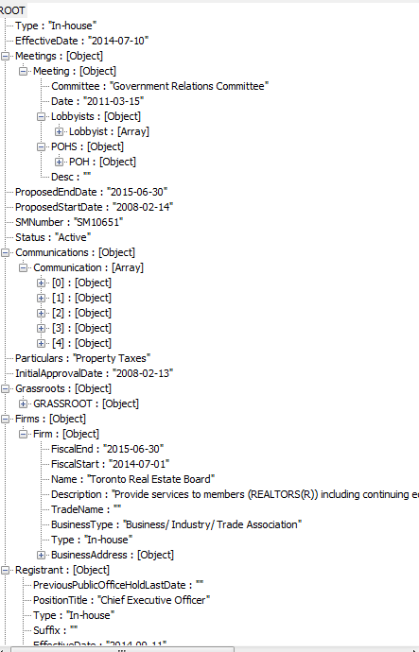

**Note:**

**Their SM table is really a generated View of the data set up for oPen Data to grab.**

**The core tables do exist.**